_____________is used to investigate or examine your blood vessels for a potential heart condition
A. angiography
B. angioplasty
C. both A and B
D. None of these
ANSWER: A
___________involves widening the narrowed arteries to treat the condition
A. angiography
B. angioplasty
C. both A and B
D. None of these
ANSWER: B
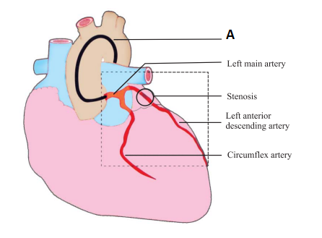
What A represents in the diagram?
A. Stent
B. Pipe
C. Wire
D. Diagnostic catheter
ANSWER: D
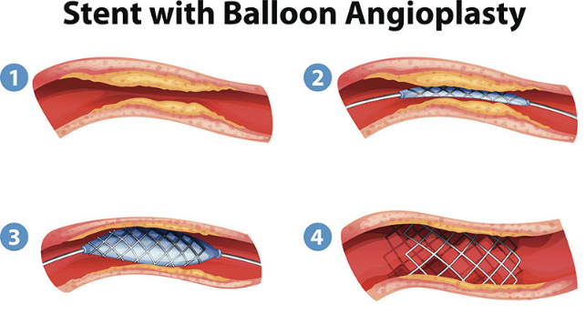
Identity step 1 in the given diagram
A. build-up of cholesterol partially blocking blood flow through the artery
B. stent with a balloon inserted into the partially blocked artery
C. balloon inflated to expand the stent
D. balloon removed from the expended stent
ANSWER: A

Identity step 2 in the given diagram
A. build-up of cholesterol partially blocking blood flow through the artery
B. stent with a balloon inserted into the partially blocked artery
C. balloon inflated to expand the stent
D. balloon removed from the expended stent
ANSWER: B

Identity step 3 in the given diagram
A. build-up of cholesterol partially blocking blood flow through the artery
B. stent with a balloon inserted into the partially blocked artery
C. balloon inflated to expand the stent
D. balloon removed from the expended stent
ANSWER: C
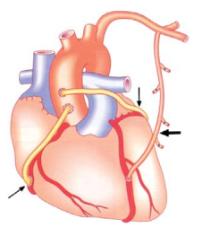
Identify the procedure:
A. Coronary angioplasty and stenting
B. A triple coronary artery bypass graft operation
C. Angiogram
D. None of these
ANSWER: B
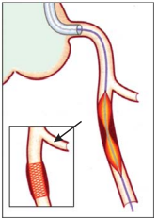
Identify the procedure:
A. Coronary angioplasty and stenting
B. A triple coronary artery bypass graft operation
C. Angiogram
D. None of these
ANSWER: A

Identity step 4 in the given diagram
A. build-up of cholesterol partially blocking blood flow through the artery
B. stent with a balloon inserted into the partially blocked artery
C. balloon inflated to expand the stent
D. balloon removed from the expended stent
ANSWER: D

In this, the patient’s chest is opened
A. Stenting
B. Open heart surgery
C. Angiogram
D. angina
ANSWER: B
The term "open" refers to the
A. heart
B. chest, not to the heart itself
C. arteries
D. veins
ANSWER: B
Heart surgery is used to correct ________in children and adults.
A. intestinal problems
B. gastric problems
C. heart problems
D. respiratory problems
ANSWER: C
The chest is opened by making an incision along the
A. sternum,
B. breastbone
C. sternum, or breastbone
D. None of these
ANSWER: C
__________are now used in nearly all angioplasty procedures
A. Wire
B. Coronary stents
C. Rod
D. Tubue
ANSWER: B
Coronary bypass and angioplasty are
A. used to treat clogged or blocked arteries
B. used to treat GIT
C. used to treat hormonal imbalance
D. used to treat cough
ANSWER: A
________surgery redirects blood around a section of a blocked or partially blocked artery in your heart
A. Bypass
B. Embedding of artery
C. Coronary bypass
D. None
ANSWER: C

